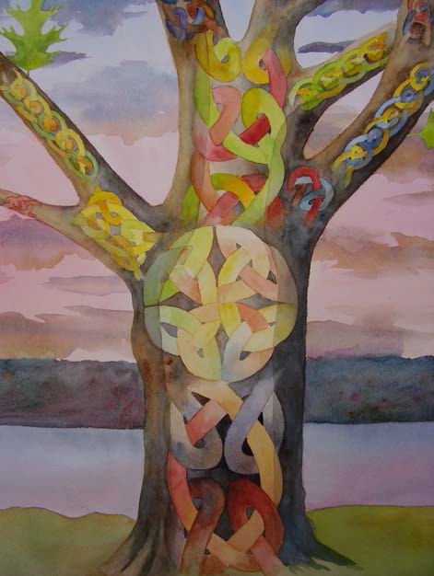
LES QUAKERS
ET LA
NOUVELLE HISTOIRE
NOUS SOIGNER AINSI QUE LA TERRE

Le groupe Nouvelle Histoire
au Friends Meeting de
Cambridge

Les quakers et la nouvelle histoire : nous soigner ainsi que la terre:

Documents de travail décrivant la vision et la compréhension du groupe La Nouvelle Histoire ,

David Anick, Juliet Carey, Mary Coelho, Marion Foster, Patty Huff, Arthur Klipfel, Judith Morse, Gwen Noyes, Cornelia Parkes, Nancy Ruggiero, Steve Stodola, and Peter Stringham, with assistance from Severyn Bruyn, David Damm Luhr, and Jessie Brown.

New Story Group Friends Meeting at Cambridge
5 Longfellow Park
Cambridge, MA 02138
cornelia@fmcquaker.org

2014
Revised 2017
French edition 2020 by Gregoire Maury

CREDITS des IMAGES

Les images sont utilisées avec la permission de la galerie de Mary Coelho, http://newuniversestory.com/newstory/

Page de couverture : Le grand Chêne Rouge
Ce magnifique chêne rouge vieux de 400 ans s’élevait jusqu’à récemment sur les rives de l’Hudson. La formation géologique de 200 millions d'années connue sous le nom d'escarpement de la palissade se situe de l'autre côté de la rivière Hudson. L'arbre était dans la cour de la maison où Thomas Berry a étudié et écrit pendant plusieurs années. Il nous a appris à passer d’une norme de réalité et de valeur centrée sur l’être humain à une norme centrée sur la Terre, afin de pouvoir découvrir, en ces temps de transition, le rôle authentique que nous devons jouer dans le grand travail que nous devons accomplir et l’importance de l'appartenance humaine à la terre et à l'univers.
.

IntroductIon

1 The Cosmos

Il y a une nouvelle histoire.
Nous avons besoin d'une nouvelle histoire, car les vieilles histoires ne fonctionnent plus. Pendant des siècles notre culture occidentale a proposé séparément une histoire «scientifique» et une histoire «religieuse», de sorte que beaucoup de quakers, ainsi que d’autres, ont perdu une histoire intégrée. Ces histoires ont objectivé le monde physique, un facteur majeur pour ouvrir la terre à une exploitation sans restriction. Ils ont également dénigré ces expériences spirituelles qui révèlent la profondeur de notre appartenance à la terre. La Nouvelle Histoire, basée sur la découverte de l’univers de l’évolution et sur d’autres percées scientifiques, nous invite à rapprocher nos expériences partagées.
Thomas Berry a écrit: «Ce n'est que lorsque nous commencerons à penser à l'univers émergent comme au royaume complet du sacré que nous pourrons dépasser notre combat actuel contre l'univers dans sa manifestation terrestre.»
La voie quaker est une tradition qui est prête et capable de recevoir les nombreux messages de la nouvelle histoire. Parce que nous croyons en la révélation continue et que nous ne sommes pas liés par des croyances, nous avons toujours été ouverts à l'intégration de la science de l'évolution avec notre foi. Nous offrons un foyer à ceux qui cherchent à nourrir leur spiritualité intégrée dans une communauté basée sur l'amour et l'action sociale.
.

De nouvelles voies en science et en philosophie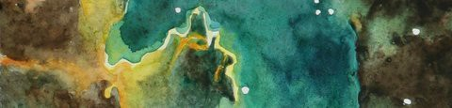
2 Etoile en formation (Détail)

Un pont entre l’histoire des sciences et l’histoire des religions est la reconnaissance d’un sens à l’évolution qui est accepté par certains scientifiques. Il y a eu une formidable augmentation de la complexité de la matière depuis le “Big Bang” il y a 13,8 milliards d’années - une augmentation qui est aussi évidente dans la suite des évolutions biologiques qui se sont enchaînées sur la Terre. Certains scientifiques pensent que l’univers n’aurait pas progressé au delà des molécules complexes au cours des dernières 13,8 milliards d’années seulement suite à des changements dû au simple hasard. Cette conception d’une direction à l’évolution contredit la vision néo-darwinienne selon laquelle les changements ne sont causés que de façon aléatoire - une vision qui nie toute importance à l’action et la causalité individuelle.
L’augmentation de la complexité physique va de paire avec l’augmentation de la conscience, qui inclue l’émergence de la conscience de soi. Nous découvrons que nous faisons partie d’un monde plein de lois physiques intriquées ainsi que d’une nouveauté spectaculaire qui est le résultat d’une formidable créativité dans le temps.
Comment pouvons nous définir et caractériser ce sens, cette direction ? Thomas Berry, un historien de la culture et prêtre catholique, et Brian Swimme, physicien et cosmologiste ont identifié trois directions au sens de l’évolution : une augmentation de la différenciation ( diversité , variation) , dans la subjectivité ( intériorité, sentience , soit la capacité d'éprouver des choses subjectivement, d'avoir des expériences vécues, l’identité) et la communion ( l’interdépendance, la mutualité ).
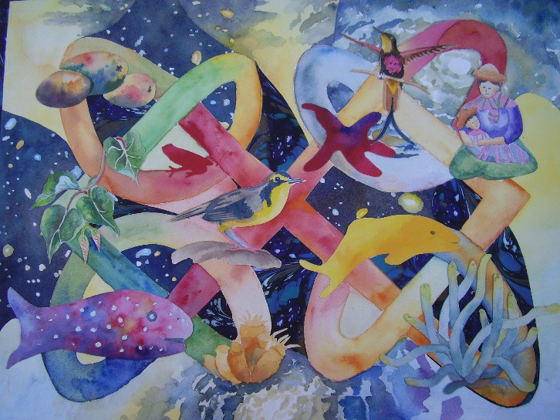
3. La créativité en cours dans le Cosmos

La compréhension de la théorie et de la mécanique quantique a apporté de grandes avancées technologiques ; cela requiert aussi que nous tous essayons d’avoir une meilleure compréhension de la nature du monde physique.La Recherche a révélé que beaucoup des lois “classiques” de la physique ne peuvent s’appliquer à certains phénomènes et que la qualité de la prédictibilité et de l’indétermination imprègne toutes les choses à l’échelle quantique.Les physiciens ont aussi découvert l’interconnectabilité à cette échelle quantique qui est un défi à notre conception de la séparation des choses. En fait, nous ne sommes pas séparés de la nature, de l’univers et de chacun d’entre nous. Nous faisons partie intégrante de cet ensemble et nous évoluons en son sein. Quel est notre rôle dans cette complexité grandissante ? Comme l’écrit de philosophe contemporain Steve McIntosh, nous expérimentons le sens de l’évolution de la conscience humaine quand nous sommes interpellés par l’expérience que la Vérité, la beauté, la bonté ( l’amour) . McIntosh continu le travail d’Alfred North Whitehead qui a argumenté que la beauté et la perfection de l’harmonie sont “ le but du développement universel”. La beauté peut être créée et expérimentée par une solution mathématique, une chanson, le travail d’un artiste aussi bien que dans la nature. Une beauté stupéfiante peut nous envahir et nous remplir d’un respect et d’une résonance intérieure qui peut donner une direction à notre vie.
.
What is our role in this increase in complexity? As contemporary philosopher Steve McIntoshvi writes, we experience the directionality of evolution in human consciousness when we are moved by experiences of

truth, beauty and goodness (love). McIntosh continues the work of Alfred North Whitehead who argued that beauty or the perfection of harmony “is the aim of universal development.” Beauty may be created and experienced in a mathematical solution, a song, or a work of art as well as in nature. Astounding beauty can fill us with awe and powerful inner resonance that may determine the direction of our lives. The New Story urges us to recognize the evolutionary movement towards deepening the experiences of truth, beauty and goodness (love), and to embrace the allure of these experiences as well.

new Paths In theology
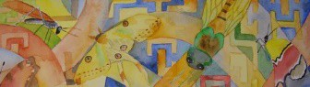
4 Nothing is Inconsequential

Emerging religious thought also offers tools to integrate the science story and the religious story as it moves away from a “theistic” God and dualistic thinking. Theism, here defined as a traditional belief in God, presumes a dualistic separation of the spiritual from the material world.
Dualistic thinking designates matter—the “stuff” of the material universe—as the subject of scientific investigation, and spirit—a supernatural quality separate from “created” matter—as the subject of theological discussion. One disastrous consequence of dualistic thinking (that is, thinking science and spirit are separate)

has been the devaluation of the natural world and concomitant degradation of the environment.

Some have rejected a traditional or theistic God by embracing non-theism or atheism, but there is another alternative. Today some Quakers, including the New Story Group, have adopted the non-dualistic approach theologians call “panENtheism,” which is neither traditional theism (God out there, transcendent, separate from the material world) nor atheism (no God anywhere). Panentheism holds that God is both immanent (permeating the entire world) and transcendent (understood nonspatially), unlike pantheism which holds that God is immanent only; that everything is God and God is everything. In panentheism, God permeates the whole universe, so that every part of it exists within God.vii In panentheism God is not omnipotent, but rather is evolving with an evolving world.

We of the New Story Group in a Quaker context use the word “God” to denote a creative, alluring, and animating force in which the whole universe exists. For us the world is an essentially spiritual matrix—all living and non-living things share a common, unfathomable divine reality.viii We integrate the domains of the material and the spiritual by embracing the oneness of all creation.
Respect and care for the environment are a natural consequence of this belief. We see this spiritual/material wholeness as an actual manifestation in every part of reality, and also as an evolutionary potential.
Panentheism thus offers an evolutionary spirituality. This potential to evolve gives us reason for hope.

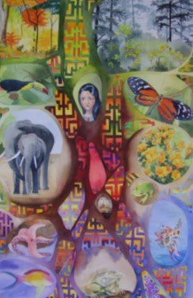

5 Tree of Life

Traditional, dualistic religions have struggled with the concept of Jesus as both human and divine. Panentheism removes this dichotomy. Central to our Quakerism is the belief that each of us carries the divine in us. We see Jesus as more completely integrated with the divine, and therefore demonstrating the highest human potential. In the context of science, the human species is evolving. In the context of the Quaker way and a New Story, Jesus is an evolutionary figure, revealing direction for the human species.

Although two thousand years is a long time in terms of human struggle, it is nearly instantaneous in the scale of evolution. However, we also see the pace of change increasing, demanding the evolution of a higher consciousness for our survival. We look to Jesus, along with many other great figures throughout the ages, as wisdom figures, teachers of love and compassion. Like many Quakers we find present-day inspiration from what we have learned of the life of Jesus. In our faith tradition, his spirit lives within all of us. One of the ways it finds life today is through our ‘leadings.’

Quakers believe that when we follow a spiritual leading we become individual agents of cosmic creativity, or what some call God’s will. We believe we must actively participate in the world’s directionality by moving toward beauty, truth and love. The Quaker term “following a leading” is central to the New Story Group. For Quakers it describes the pull of something fundamentally true— although perhaps not yet recognized in the wider community—to which we feel compelled to respond.

For us, the New Story is such a leading. We seek to share it more widely because we believe it is part of the change in worldview that is crucial for our survival. Science tells us that evolution is now in our hands, and this includes political, ecological, and moral evolution.

new Paths In grouP decIsIon- MakIng
6 Unexpected Interconnectedness (Detail)

One of the strengths that Quakers bring to this challenge is our group decision-making process. The Quaker process goes beyond voting or reaching consensus. In a Quaker meeting the worshippers wait in openness to the Spirit. A “gathered” meeting is one in which the group senses a shared mystical experience. Likewise, our meetings for business, based in worship, seek a truth that lies beyond individual definitions. This process, though often slow, is a method of finding the shared, higher intelligence of the group called the “sense of the meeting.” Out of this practice have appeared revolutionary ideas and spirit-led actions.

The evolutionary spirituality of the New Story holds that human species is evolving toward higher consciousness, and that this consciousness is necessary for our survival. From this it follows that striving for higher consciousness is an evolutionary imperative. We see the Quaker method of decision-making as a process for achieving that.

We believe that at this critical time in Earth’s evolution, both individuals and groups—religious or otherwise—are called to a deeper awareness of the consequences of their decisions. Our study group found the book Presenceix was enlightening, in showing how corporate decision-making

can evolve in ways consistent with Quaker decision- making. It illustrates a process of ‘emergence,’ that the authors developed which can address corporate, government or social issue challenges. Emergence involves opening ourselves to transformation, individually and collectively, through deeper knowing. The Quaker practice described above encourages a higher consciousness to emerge with the participation of the Spirit. A new understanding brought forth through ‘emergence’ is just that.

ecology
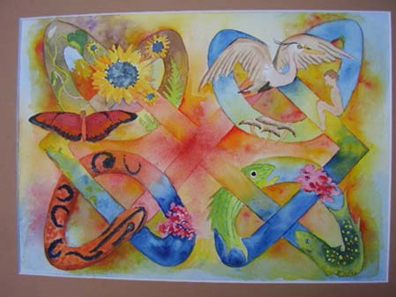
7 The Unfolding Light

Western civilization perpetuates a powerful underlying assumption: the separation of the material from the spiritual. The cultural heritage that most of us share casts

the earth as a resource that needs to be tamed and “used” (or as we’ve found) misused. Today science has given us unimaginable powers, with technologies resulting in wondrous achievements; but these powers have also led the natural world to the edge of disaster.

As humans we can use our spiritual insight as well as our science and technology to change directions. We believe Quakers can contribute to a fundamental paradigm shift that has the capability of pulling us back from the brink of global climate disaster.

Our task, as we embrace a New Story, is to align ourselves with the basic and all-encompassing directionality of the earth’s complex systems. While science has been illuminating the glories of these systems, our civilization has been defiling them. Time is running out for us to reconsider the choices we make in our individual lives and their effect on the world’s living systems. Each of us must decide if we want to be a positive force for earth’s biosphere. We believe that committing to a process of alignment with the creative forces of evolution is a spiritual endeavor as well as an urgent calling to which we must respond.

destructIve Forces In coMPlex systeMs
8 Smoke Stacks (Detail)

We cannot embrace the New Story without addressing the challenge of the many destructive forces around us. We act both as individuals and as part of multiple systems. Cultural, social, cultural, governmental and corporate systems are complex and often driven by narrow, short term, and self-centered interests. At their worst, some might call many of these systems licensed evil.

We may see the mounting injustices and environmental degradations as too intractable, remote or enormous for any small group or individual to make a difference. Yet we also see examples of astounding breakthroughs set in motion by a few well-informed, passionate, and spiritually grounded individuals. Consider the histories of abolition, of civil rights, of the Americans with Disabilities Act. Many of their champions have been motivated by a spiritual leading.

The New Story invites us to discern our part: to recognize those systems we are most involved in and to pursue ways to effect change—perhaps even with a constructively disruptive voice. As we lift up our concerns, we find others who share them, and who can join in the effort to effect change.

conclusIon
9 The Center of a Galaxy (Detail)

We believe that committing to this integrative process, and aligning ourselves with the creative forces of evolution is a spiritual endeavor as well as an urgent calling. Where does this place us?

We have taken heart from the work of Kenneth Boulding,x a Quaker economist of the 20th century, for whom “the reality of religious experience is no less real than the reality learned by the senses [and science].” Boulding saw the evolutionary potential of Quakerism as far from exhausted; indeed, as still very high. He described Quakerism as a spiritual development “in a sense premature, before its time. The Quaker belongs to a kingdom that is not yet. This is an awkward loyalty to have. But it is an attitude and loyalty which points towards the future rather than toward the past…” In his words, “the Society of Friends has a great intellectual task ahead of it… [to translate its] insights into a conscious understanding of the way in which the kind of love which we treasure and covet can be produced, defended, and extended.”

Like Boulding, we treasure the many sources of psychological as well as spiritual insight that inspire a higher consciousness. Yet, while we cannot know where this New Story will lead, we invite you to join us in helping it unfold.xi

end notes

iThe New Story as a term was first used by Thomas Berry in his essay by that name published in 1978.
ii Brian Swimme and Thomas Berry, The Universe Story (San Francisco: Harper Collins, 1992)
Thomas Berry, Dream of the Earth (San Francisco: Sierra Club Books, 1988)
Brian Thomas Swimme and Mary Evelyn Tucker, Journey of the Universe (New Haven: Yale University Press, 2011).
Philip Clayton, Mary Coelho and the New Story Study Group Quakers and the New Story, Essays on Science and Spirituality, Friends Meeting at Cambridge, 2007
Mary C Coelho, Awakening Universe, Emerging Personhood (Lima, Ohio: Wyndham Hall Press, 2002)
ii Thomas Berry, The Christian Future and the Fate of the Earth (Maryknoll, NY: Orbis Books, 2009) pp. pp. 111, 112.
iii Peter B. Todd, The Individuation of God (Wilmette, Illinois: Chiron Publications, 2012) p. 13. Citing Paul Davies.
Nona Coxhead, The Relevance of Bliss (London:
Wildwood House, 1985) p. 132. Citing Fred Hoyle
ivLouis M Savary, Expanding Teilhard’s “Complexity- Consciousness” Law, Teilhard Studies, Number 68,
Spring 2014
v Swimme, Brian and Thomas Berry, The Universe Story, pp.
71-78.
viSteve McIntosh, Evolution’s Purpose (New York: Select Books Inc., 2012)

viiMichael W. Brierley, Panentheism: A Postmodern Revelation, In Whom We Live and Move and Have Our Being, Eds. Philip Clayton and Arthur Peacocke, (Grand Rapids, Michigan: Wm. B Eerdmans Publishing, 2004),
p. 5.
viii David Ray Griffin, God and Religion in the Postmodern World (Albany, NY: State University of New York Press, 1989), p. 67.
ix Peter Senge, C. Otto Scharmer, Joseph Jaworski and Betty Sue Flowers, Presence (New York: Doubleday, 2004)
x Kenneth E. Boulding, The Evolutionary Potential of Quakerism (Wallingford, Pennsylvania: Pendle Hill Pamphlet #136, 1964)

xi

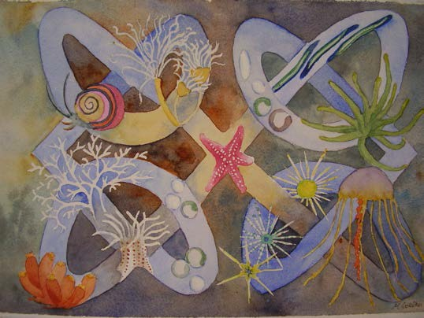

10 Magnificent Cosmos

Reading List
Berry, Thomas, Dream of the Earth (San Francisco: Sierra Club Books, 1988)
Berry, Thomas, The Great Work (New York: Bell Tower, 1999)
Boulding, Kenneth E., The Evolutionary Potential of Quakerism (Wallingford, Pennsylvania: Pendle Hill Pamphlet #136, 1964)
Bourgeault, Cynthia, The Wisdom Jesus: Transforming Heart and Mind—A New Perspective on Christ and His Message (Boston: Shambala, 2008)
Bourgeault, Cynthia, The Wisdom Way of Knowing (San Francisco: Jossey-Bass, a Wiley Imprint, 2003)
Brierley, Michael W., “Panentheism: A Postmodern Revelation,” In Whom We Live and Move and Have Our Being. Philip Clayton and Arthur Peacocke, eds. (Grand Rapids, Michigan: Wm. B. Eerdmans Publishing, 2004)
Clayton, Philip, Mary Coelho and the New Story Study Group, Quakers and the New Story, Essays on Science and Spirituality (Friends Meeting at Cambridge,
2007) http://www.quakerearthcare.org/pamphle t/quakers-and-new-story
Coelho, Mary C., Awakening Universe, Emerging Personhood (Lima, Ohio: Wyndham Hall Press, 2002)

Deep Time Journey Network: http://www.deeptimejourney.org
Fox, Matthew, What is Creation Spirituality? http://www.matthewfox.org/what-is-creation- spirituality/#historical
Griffin, David Ray, God and Religion in the Postmodern World: Essays in Postmodern Theology (Constructive Postmodern Thought) (State University of New York, 1989)
McIntosh, Steve, Evolution’s Purpose (New York: Select Books Inc., 2012)
Morgan, Jennifer, Born with a Bang, From Lava to Life; Mammals Who Morph, a trilogy (Nevada City, CA: Dawn Publications, 2002, 2003, 2006)
Peacocke, Arthur, Preface, In Whom We Live and Move and Have Our Being. Philip Clayton and Arthur Peacocke, eds. (Grand Rapids, Michigan: Wm. B Eerdmans Publishing, 2004)
Senge, Peter, C., Otto Scharmer, Joseph Jaworski and Betty Sue Flowers, Presence (Doubleday, 2004)
Swimme, Brian, The Hidden Heart of the Cosmos
((Maryknoll, New York: Orbis Books, 1996)
Swimme, Brian and Mary Evelyn Tucker, Journey of the Universe (Yale University Press, 2011)
Swimme, Brian and Thomas Berry, The Universe Story
(New York: Harper San Francisco, 1992) Templeton Conversation, Does the Universe Have a
Purpose? http://www.templeton.org/purpose/ Tucker, Mary Evelyn and John Grimm, Thomas Berry:
Selected Writings on the Earth Community, (Modern Spiritual Masters, Orbis Press, 2014)

about the new story grouP

The New Story group was formed in 2004 when several people in the meeting who shared a common recognition of the importance of the New Story wanted to explore it further. The group has continued to grow and attract new members who are seeking a spiritual home and new visions for hope. Our goals have been to educate ourselves and spread the news of the New Story.

In our monthly meetings and yearly retreats we have discussed some of the readings listed above and struggled for a fuller understanding of the concepts expressed in this pamphlet and how they relate to the Quaker way.
We continue to explore new meanings of the word “God”. Recognizing that transformative experiences are intrinsic to our identity as earth beings, we have experienced in individual ways personal spiritual growth and transformation.

We have reached out for wider audiences through publications and workshops. The original group (Mary Coelho, David Damm-Luhr, Arthur Klipfel, Nan Lee, Gwen Noyes, and Severyn Bruyn, consultant) along with Philip Clayton published the pamphlet Quakers and the New Story, Essays on Science and Spirituality in 2007. We hosted showings of several of Brian Swimme’s videos: The Canticle of the Cosmos (a 12-part series) and The Powers of the Universe (a 10 part series). We have also shown The Journey of the Universe with Mary Evelyn Tucker as part of a six week workshop. Mary Coelho and Cornelia Parkes gave a workshop at Friends General Conference on The Depth of our Belonging, the summer of 2012. In previous

years Mary had led several workshops at FGC inspired by the New Story. In the fall of 2013 we co-sponsored with Cooperative Metropolitan Ministries a day with Mary Evelyn Tucker and John Grimm on Evolving Spirituality for the 21st Century: Are the Sciences Providing a New Common Ground for the World Religions? Mary Coelho presented a paper on “The Depth of our Belonging to the Unfolding Story” at this workshop. The winter of 2014, Cornelia Parkes created and taught a First Day School curriculum for 3rd through 5th grades called Quakers and Dinosaurs based on three books by Jennifer Morgan, Born with a Bang, From Lava to Life, and Mammals Who Morph.

This pamphlet is the product of the collective writings from our 2014 spring retreat and many revisions and consultations with the group. Mary Coelho and Cornelia Parkes gave a workshop at New England Yearly Meeting Sessions, summer, 2014, on the contents of the pamphlet and received further feedback. We hope this pamphlet conveys to some degree the importance to us of our work together as we grapple with new and ancient questions.

