HOW CONNECTION TO NATURE CAN SUPPORT THE DISMANTLING OF OPPRESSION (Zoom)
The next meeting of the FMC New Story Group is Monday, January 22, on Zoom from 7:00 to 9:00pm. Come at 6:30 for fellowship. First timers are always welcome!
The topic for this month is “How Connection to Nature can Support the Dismantling of Oppression” based on a presentation by Dr. Paul Aston, head of the Manzanita School in Topanga Canyon, CA. The school offers college preparatory academics in a wilderness setting that promotes a deep connection to nature. Manzanita is the only school of its kind in the country!
To participate in this event click this link or call 1-646-558-8656 and provide the Meeting ID 875 6881 1869 and passcode 101225.
For more information and list of resources, please visit the New Story web page here. To be placed on the email list for New Story News and announcements of future meetings contact Cornelia Parkes new-story@fmcquaker.org.
NEW STORY NEWS
The New Story is in the news everywhere if you know where to look for it. Here are some of our favorite places.
Deeptime Network
- “Cataclysm & Collective Emergence: Discernment Using Deeptime Principles” by Stephan Martin, Director, Deeptime Leadership & Wellbeing Program. Read article here.
- Shaping Noospheric Adults with “MONTESSORI COSMIC EDUCATION: Early Childhood through the Secondary Level”
This presentation by Jennifer Morgan, DTN president, was part of the N2 Conference: The Noosphere at 100: The Future of Human Collective Consciousness sponsored by the Human Energy Project, Berkeley, CA, Nov. 17-19, 2023. For more info and to watch the recording, click here to watch.
- Go to the Deeptime website for more articles and link to other sites such as the following.
N2 Conference — The Noosphere at 100: The Future of Human Collective Consciousness
- Friday, November 17 Ilia Delio on “Teilhard and the Noosphere” start at 4:18:33, almost at the end. It continues on a new tape.
“Human energy presents itself to our view as the term of a vast process in which the whole mass of the universe is involved. In us the evolution of the world towards the spirit becomes conscious’” Teilhard de Chardin (1881-1955)

The New Ecozoic Reader
- Special Issue – Reflections the book COSMOGENESIS
Contains an article by Mary Coelho.
- “THE ECOZOIC WAY in Religion, Ethics & Law: Understanding and Applying the ESSENTIAL TEACHINGS OF THOMAS BERRY.” Eight Week Course with Herman Green, JD, DMin. Starts March 4. More info here.
Yale Forum on Religion and Ecology
- “Listening to Other Voices: A Faith Perspective from Teilhard de Chardin and Thomas Berry.”
February 15, 2024, Online and in-person at 7:00-8:30pm EST with Mary Evelyn Tucker and John Grim. Register here.
- And much more!

Women Are Coming!

By Wanjira Mathai December 6, 2023
Africa is in danger of becoming the epicenter of the climate crisis, but the continent also holds the potential to fight it.
“There are moments in one’s life where it seems like everything that has already happened meets everything that is yet to come. The legacies of the past confront the possible futures, and we are asked a question: What step will you take that honors the past but doesn’t wreck the future?” Read the full article from the New York Times here: http://archive.today/IYpHz
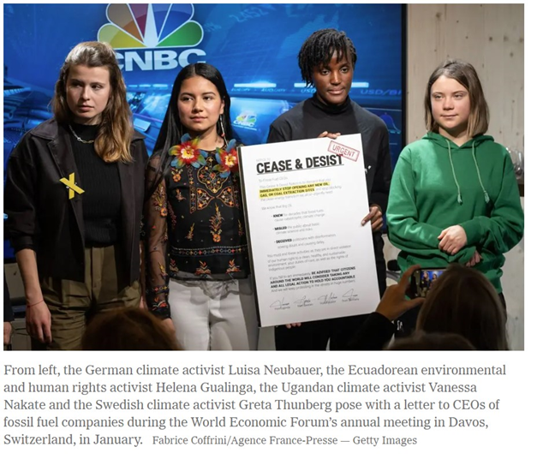

There is more out there than I have time to explore. Keep your eyes open!

