Symbiotic Earth

How Lynn Margulis rocked the boat and started a scientific revolution

Introduction
“We must reevaluate our entrenched ideas and preconceived notions.” Evolution is not the result of completion—it is the result of cooperation.
Symbiosis. Interdependence; a close union of two dissimilar organisms; a cooperative relationship
Symbiosis is the fundamental driver of evolutionary change.

Chapter 1: How Lynn Margulis coerced me into making this film
She said that I need to show that Neo-Darwinism is a capitalist zeitgeist—American empire political propaganda and explain the Gaia theory.
Gaia theory. Life on earth regulates its own environment.
The certainties of the Twentieth Century are now crumbling.

Assumption 1
In science we can never really know the truth, because our knowledge s always biased and incomplete. We deal with approximations. We can get closer to the truth. Proof belongs to logic and mathematics, not science.

Chapter 2: How science gave us permission to exploit the earth (from reductionism to systems thinking)
The biosphere is dominated by the microbial world.
The environment modulates beings and beings modulate the environment.
Scientific facts are the product of “thought collectives” and can change as the culture changes. You can get stuck in a current thought collective and not be able to see the “trained incompasities.” You don’t see things because you are taught not to see them. If everybody is thinking alike, then somebody isn’t thinking. We are at war with nature. The mechanistic view of nature is that we can exploit the environment. This is the thought collective that Margulis fought against.
Where did the mechanistic worldview come from? It developed in the 16-17th century scientific revolution led by Galileo, Descartes, and others. They discovered that one could study the world mathematically, and thus predict and control nature. Also, they believed that the universe is nothing more than a machine.
When you are trained as a scientist, you are told that you have to develop a kind of detached objectivity. You mustn’t allow your feelings to get involved. Science distances us from the world. The machine metaphor was really powerful, but it was taken as reality.
Reductionism. Understanding a system by breaking it down to its component parts in isolation.
The machine metaphor gives a mathematical, mechanistic, reductionist science, which is a powerful but limited way of knowing.
Other ways of knowing: When actors start interacting together, we often get emergent properties.
Emergent properties. Properties that cannot be predicted from the knowledge of the properties of the parts in isolation.
The studies of emergent properties gives a more holistic style of science, called systems thinking.
Systems thinking. “Systems thinking is a holistic approach to analysis that focuses on the way that a system's constituent parts interrelate and how systems work over time and within the context of larger systems. The systems thinking approach contrasts with traditional analysis, which studies systems by breaking them down into their separate elements. Systems thinking can be used in any area of research and has been applied to the study of medical, environmental, political, economic, human resources, and educational systems, among many others.”
The major problems of our time are all interconnected—energy, climate change, poverty, technology, economics, management. They cannot be understood in isolation.
We need to think in terms of patterning, interrelationships, and feedback loops, as opposed to linear thinking.
Linear thinking. cause effect

Feedback loop. cause effect

In this kind of thinking the focus shifts from objects to relationships between the objects. Life is a connected phenomenon. There are no independent organisms, only a system.
There is a revolution in the life sciences from a mechanistic view to a systemic view of life. This is a profound change.

chapter 3: Confronting the neo-darwinian capitalistic zeitgeist—how science gave us permission to exploit each other
Neo-Darwinism took the life out of biology. Darwin was right that all life on earth has a common ancestry and in his theory of natural selection.
Natural selection. More are born than can survive. Those who survive pass on their characteristics to the next generation. “Each slight variation, if useful, is preserved…” and gradually this results in evolutionary change.

Neo-Darwinism. In the 1930’s and 40’s scientists combined Darwin’s theory of evolution by natural selection with Mendel’s laws of inheritance (which has become genetics) to become the modern synthesis. The variations from one individual to another that lead to evolutionary change are caused by differences in their genes and these differences are a result of mistakes that happen when the genes are copied during reproduction. These errors are called “random genetic mutations.”
Neo-Darwinism dominated science during the 50’s to the exclusion of all other theories. They ridiculed Jean-Batiste Lamarck, who allowed that acquired characteristics could be passed down to the next generation—a theory that does not contradict Darwinism. Why did this happen? Science and politics are intertwined. Lamarck was associated with the Russian communists.
Margulis differed with the Neo-Darwinists. She saw little evidence for specie’s change due to random mutations. For her, new species come from organisms adjoining with one another. This theory allows for evolutionary leaps.
Neo-Darwinists scorned her and called her a creationist.
Creationism. A doctrine or theory holding that matter, the various forms of life, and the world were created by God out of nothing and usually in the way described in Genesis.
She replied that Neo-Darwinists are “…a minor 20th century religious sect,“ because they promoted their own dogmatic belief system.
Neo-Darwinism is based on competition.
The symbiotic view is based on cooperation.
Where did the metaphor of survival of the fittest come from? Darwin’s social context was Victorian capitalism, and he was a wealthy man, so he naturally absorbed competitive ideas. Darwin’s theory of natural selection based on the struggle for existence is nothing more than laissez faire socio-economic theory applied to nature. We see it in nature because it is a reflection of our social world. Darwin did not originate the phrase “survival of the fittest.” ”Fittest” can be defined mathematically as the number of off spring an organism has. Note that the title of Darwin’s seminal book is The Origin of the Species by Means of Natural Selection or the preservation of favored races in the struggle for life.
The theory of the survival of the fittest is a dangerous metaphor. It has been turned into a law of nature and used to justify brutal competition and global economic exploitation of people and the environment as well as racism and genocide.
Richard Dawkin’s The Selfish Gene is another dangerous metaphor. It promotes the individual over the power of the community, because it is opposed to socialism and communism.
Theories that are really metaphors distance us from the facts and, when presented as science, are taken as truth. The survival of the fittest and the selfish gene are the bases of the neo-Darwinian capitalistic zeitgeist, which is the pervasive belief that humans are genetically selfish and that success comes only by winning in competitive struggle. All else is childish sentimentality.
Choosing how we look at nature makes all the difference. Neo-Darwinists see in nature independent selfish individuals struggling for existence. Margulis sees interdependent communities of organisms.
How does the new paradigm change the way we behave? Federico Mayor Zaragoza, President of the Cultural Foundation for Peace in Madrid, Spain, replies that we are now approaching a new beginning and must have a radical change from the world of force to a world of word in order to find a peaceful solution to conflicts. The competition model will eventually become lethal.

chapter 4: Lynn Margulis’ lifelong quest
Previously, all life was divided in two—animals and plants. For Margulis life has five kingdoms:
- Bacteria (very small 1/1000 of a millimeter)
- Protoctists (single or multicellular, includes amoeba, paramecium, and kelp)
- Fungi
- Animals
- Plants
Virus. Smaller than bacteria contain DNA and RNA, but cannot reproduce by themselves so do not meet the definition of a life form.

Genome. A collection of DNA molecules with a cell.

DNA. A long Helix shaped molecule made up of sequences of four different molecules—Adenine, Thymine, Guanine, and Cytosine (ATGC)—called nucleotides. The arrangement of nucleotides is the storage system of a cell.

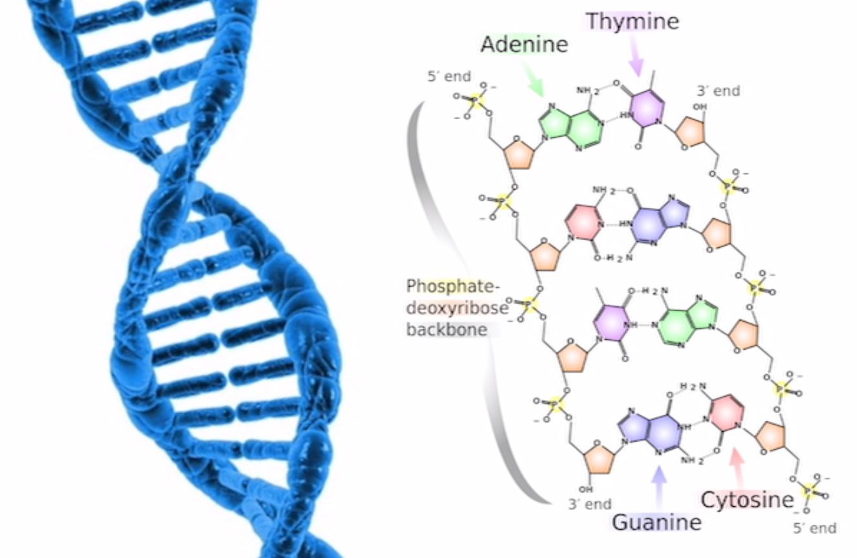
The unit of life on earth is the cell. There are two types of cell:
Prokaryotic. A bacteria like cell that has DNA but no nucleus.

Eukaryotic. All other cells in animals, plants, fungi, and protists. They have a nucleus with DNA arranged in chromosomes.

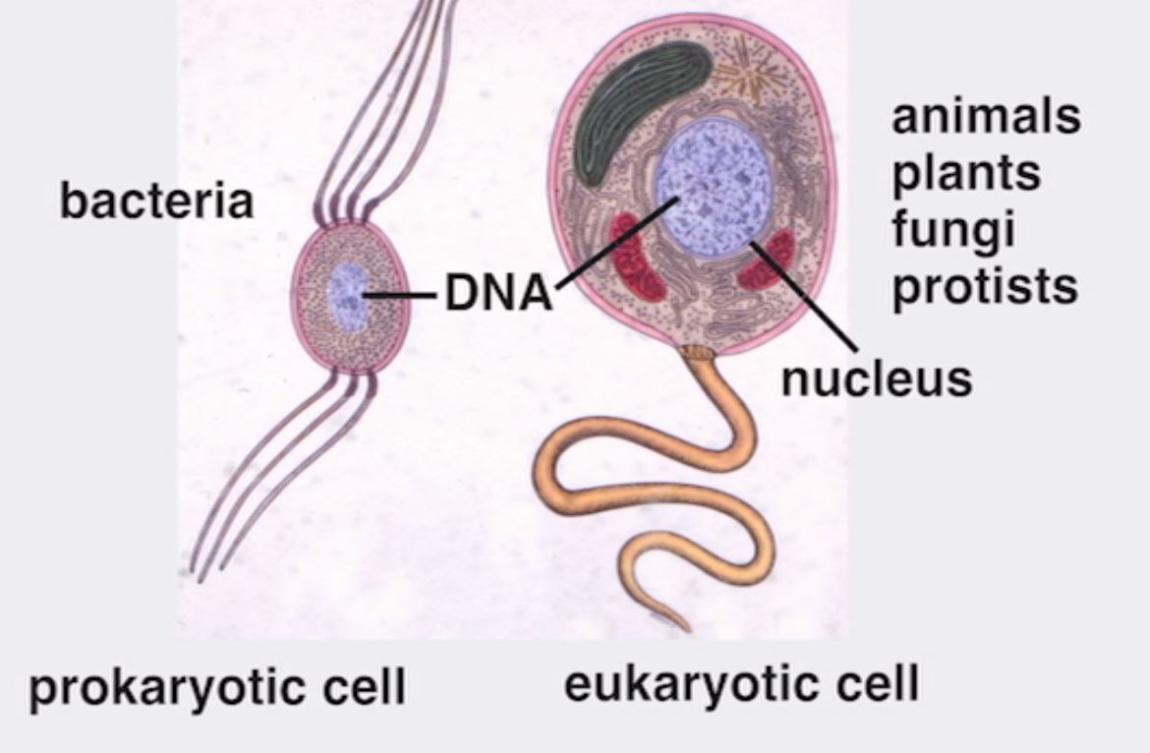
A central question to Margulis’ work was “How did mitosis evolve?”
Mitosis. The process of cell division.
Life evolved over 3 billion years ago. The nucleated cell evolved 2 billion years ago. So you have about a billion and a half years between the origin of life and the nucleated cell. During that time all kinds of things happened: photosynthesis evolved; movement, nitrogen fixation, methanogenisis, CO₂ fixation (5 different kinds)—but all on a small scale and in the water.
The question “How did we get from a bacterial cell to a nucleated cell?” directed her whole career and upset the neo-Darwinian establishment.
Mitochondria. Organelles in eukaryotic cells that have their own DNA.

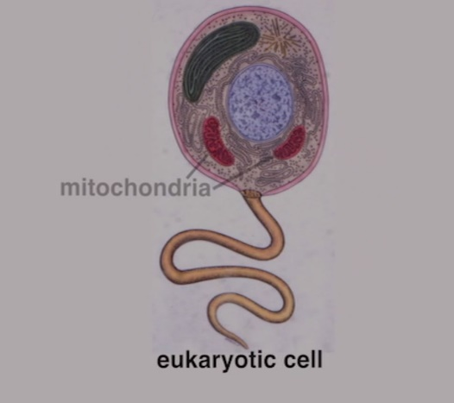
Margulis’s 1967 landmark paper “On the Origin of Mitosing Cells” proposed that the nucleated cell arose from a series of symbiotic mergers between already existing bacteria. Other scientists had already proposed similar ideas, but Margulis put it in a geo-chemical context.
Two thousand million years ago (+/- a hundred million years), the oxygen given off by blue green algae (which is still around today) was responsible for the transition of the earth’s atmosphere from having no oxygen (anaerobic) to present day levels of 20% oxygen. This oxygen in the atmosphere poisoned just about everything. Symbiosis was a way of coping with the increased oxygen. Two very different kinds of bacteria got together and were able to use the oxygen. One broke down sugars without help of oxygen and a second took the broken down products and with oxygen burned them to derive a lot of energy. The two together made a complex that after a long time and many changes became a very successful organism that is the ancestor to all the higher cells.
We are made out of deeply collaborative bacteria. Her ideas were upsetting to the established scientists who ridiculed them, but she was vindicated. Chloroplasts (the green part of plants) were traced to bacterial ancestors.

chapter 5: working together: how did she do it all?
Lynn Margulis did not “discover” symbiosis. She promoted symbiosis as a source of evolutionary innovation, the idea that we can study cells in an evolutionary and ecological context. She put symbiosis as an early driver of evolution, put microbes back into biology as life-giving forces, and championed the diversity of microbes, especially protists.
It is an American myth that individual heroes make discoveries, but what individuals can do is promote different ways of seeing and doing.
Some of Margulis’ illustrious predecessors are
Kozo Polyanski (1890-1957)
Framintzyn (1845-1905)
Mereschkhovski (1869-1910)
Ivan Wallen 1883-1969)
Wallen wrote “…bacteria that are ordinarily associated with disease are the fundamental causative factor in the origin of the species…” Boris Mikhailovich and Kozo Polyanski published Symbiogenesis—a New Principle of Evolution. Margulis also had many collaborators.

Proposal for the early evolution of life
The early evolution of life saw 3 symbiotic fusions of four different types of bacteria that joined forces to create all the other organisms.
- Fermenting archaebacteria joined swimming bacteria (spirochetes) to create anaerobic protoctists that have a nucleus and internal structures necessary for mitosis.

- Oxygen breathing bacteria joined with the anaerobic protoctists to form an oxygen-breathing (aerobic) protoctist. The oxygen-breathing bacteria became the mitochondria. These evolved into all animals and fungi. Animals have blastulas and two genders, are heteromorphic, with chromosomal determinants. Fungi have spores with conjugation and many genders.

- Photosynthetic cyanobacteria joined with oxygen-breathing protoctists to create a photosynthesizing, oxygen-breathing cell that evolved into algae and then all the plants. Plants reproduce maternally, retained embryos, and have complementary genders with varying genetic determinants. The cyanobacteria became the chloroplasts.
The first fusion was the most controversial—the merger of archaebacteria and spirochetes. Spirochetes are so called because they spin like corkscrews. (Today they cause Lyme disease.) Margulis proposed that spirochetes became the cell’s cilia and flagella, which are now called ungel podia. Spirochetes are also involved in the origin of mitosis.
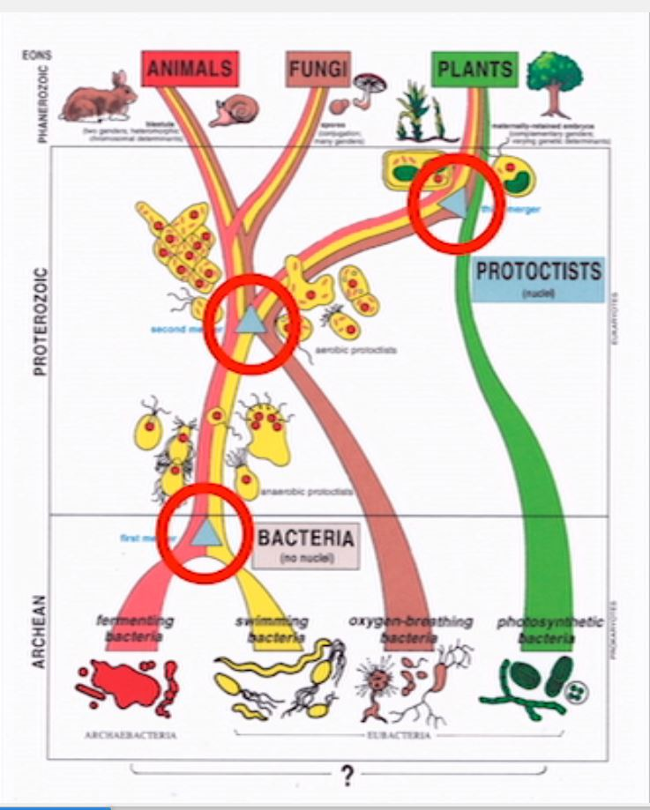

A film by John Feldman. Hummingbird films. 147 minutes. www.bullfrogfilms.com. Margulis challenged the male-dominated scientific community and proposed a new approach to understanding life.
https://searchcio.techtarget.com/definition/syste s-thinking
https://www.merriam-webster.com/dictionary/creationism

