Symbiotic Earth

How Lynn Margulis rocked the boat and started a scientific revolution

PART II

Chapter 6: Bacteria Run the Planet
Bacteria are our ancestors! Microbes run the show and have been doing so ever since life began 3.5 billion years ago (BYA). They have been regulating the atmosphere, regulating the climate, recycling nutrients, creating complex ecosystems, and communicating with each other. Some rocks are made from millions of dead bacteria.
Stromatolites are layered mounds, columns, and sheet-like sedimentary rocks. They were originally formed by the growth of layer upon layer of cyanobacteria, a single-celled photosynthesizing microbe that lives today in a wide range of environments ranging from the shallow shelf to lakes, rivers, and even soils.
Most bacteria metabolisms, of which there are many, evolved in the first million years.
Metabolism is the flow of energy and matter through a network of chemical reactions within an organism that allows it to maintain and perpetuate itself.
Human metabolism is no more complex than the metabolism of some bacteria billions of years ago. Three BYA in the Archean Era anaerobic bacteria ecosystems created the fabric of life—the bacteria mat. Most people think bacteria are a disease, but we are 10% dry weight bacteria. We need them.
Cyanobacteria have formed a mat in the sand. They are also called the blue greens, because they are photo synthesizers.
Photosynthesis is the process by which green plants and some other organisms use sunlight to synthesize foods from carbon dioxide and water. Photosynthesis in plants generally involves the green pigment chlorophyll and generates oxygen as a byproduct. They capture energy from the sun and use it to make sugars.
Cyanobacteria are the highest level of evolution because they live off carbon dioxide and water and that’s all!
The other major photo synthesizers are the purple sulfur bacteria. The use hydrogen sulfide (H₂S) for photosynthesis and give off sulfur. They are the ancestors of the blue greens, which also live on hydrogen but give off oxygen. The H₂S bacteria are limited to areas of volcanic action, but the blue greens can go anywhere there is oxygen and so they run the planet. They are the ultimate food supply. These bacteria are inside all green plant bodies.
White bacteria do not need light. They can take carbon in the dark, but their source of energy is the hydrogen sulfide that oxidizes to sulfate.
The waste of one is the food of the other. That’s how the ecosystem goes around. If this didn’t happen, we would be drowning in waste, the equivalent of urine or feces.
Humans are drowning in our own waste.
The bacterial communities recycle everything, and they persist through time. If we could listen/understand what they are doing we would recognize that you can’t just throw things out. There is no OUT out there. Garbage goes around. Bacteria have solved that issue and people have not. We are ruining our environment. The bacteria are producing an environment that is livable. So, we have lots to learn from them.
Bacteria run all the cycles: the nitrogen cycle, the carbon cycle, and the oxygen cycle.
What can’t they do? They can’t talk; they don’t have bones; and they can’t make wood. 400 million years ago (MYA), plants learned to make wood and life became vertical.
Bacteria make all the sugars, all the acids, all the DNA and RNA, membranes, fatty material, and all the slime. They precipitate iron and make magnets. They make rocks. They made the iron deposits 2 MYA that today we mine to make steel to make cars.
Bacteria do not go extinct. They don’t have species. They transfer their genes back and forth promiscuously. There is one planetary bacteria organism that has been running the planet ever since life started. What is all life on earth? It is either bacteria in their own communities or in new communities of bacteria as in plants and animals.
If you listen closely at night, you can hear bacteria singing: “Got along without ‘cha before I met ‘cha, I’ll get along without ‘cha now!”

Chapter 7: Symbiosis is the Way of Life
We are symbionts on a symbiotic planet.
Lichen is the symbiosis between the algae, which is the green part that is making the food, and the fungi, which is the white part. It looks like a plant, but it is not a plant.
Lichen is a composite organism that emerges from algae or cyanobacteria living among the filaments (hyphae) of two fungi in a mutually beneficial symbiotic relationship. The fungi benefit from the carbohydrates produced by the algae or cyanobacteria via photosynthesis. The algae or cyanobacteria benefit by being protected from the environment by the filaments of the fungi, which also gather moisture and nutrients from the environment, and (usually) provide an anchor to it.
Symbiosis is the living together or unlike organisms. It does not apply to groups of the same species living together. A bee and a flower are not symbiotic, because they do not live in physical contact with each other for a prolonged period of time. Some symbiotic relations are mutually beneficial, but others are pathological. The symbiotic relationship can change from beneficial to necrotrophic when one organism kills the other.
Symbiosis is the way of the world. There are many different kinds.
Mycorrhizae are symbiotic relationships that form between fungi and plants. The fungi colonize the root system of a host plant, providing increased water and nutrient absorption capabilities while the plant provides the fungus with carbohydrates formed from photosynthesis.
The interface between the plant and the soil is not so much the root, but it is much more the mycorrhizal fungus that can reach very far from the root and is able to get all the nutrients that are essential for the growth of the tree from the rock by production of organic acid. Another function is draught tolerance. This fungus, mycelium can go into small particles of soil and still get some moisture and water.
I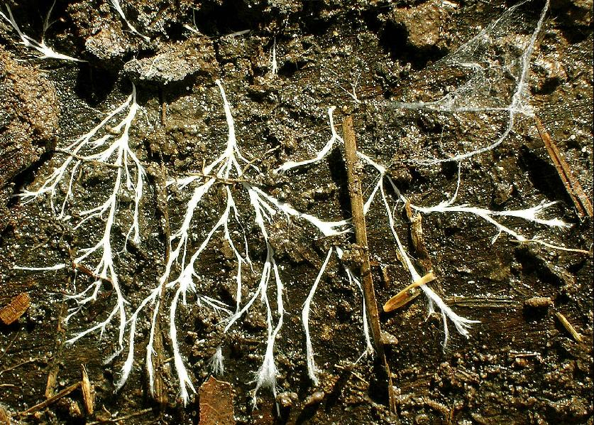
Mycelia
The network of microscopically thin tubular filaments penetrate into soil and rock to find water and nutrients extending the root system of the plants. Deep plowing destroys the mycorrhiza, but mycorrhiza has the potential to revolutionize agriculture. In order to grow crops in depleted soil, mycorrhiza are being reintroduced into the system. In a laboratory in India mycorrhiza are harvested and made into a tablet form that can be delivered to farmers.
The plants give the mycorrhiza food, while the fungus helps the plant to find water and nutrients, to grow on rocks, and amazingly to communicate with each other. So if one plant is attacked by insects or fungus it will mount a chemical defense and will send a message to neighboring plants through the mycorrhiza so that those plants can prepare their defense. So there is a sort of social organization between the plants through the mycorrhiza fungi. This communication has been will demonstrated.
All plants have the same symbiotic relation with fungi, which permitted them to get out of the sea and start colonizing the terrestrial system. Plants actually were never really just plants, but are plant/fungal consortia.
The same for animals. Coral is a consortia of the coral genome and its products and a symbiotic algae called zooxanthellae (zo-zan-THELL-ee). Coral bleaching happens when the water is too warm and the coral loses it symbiotic algae so that the coral cannot get the carbon they need for photosynthesis and they die.
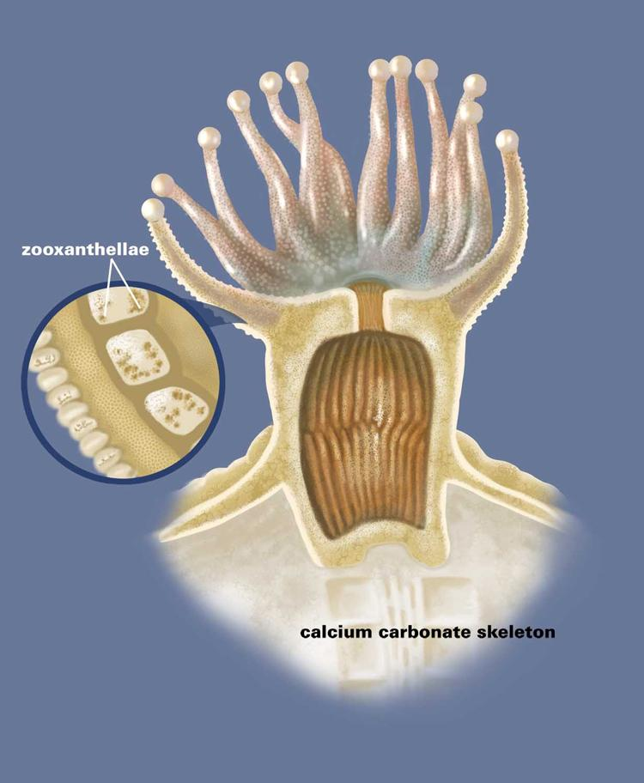
Zooxanthellae
A cow is a consortia, because it cannot digest cellulose without its symbiance. Any animal that cannot develop its digestive system without its gut-associated lipoid is a consortia.
You have a symbiotic relationship with your eye lash mites and your underarm bacteria and your between the toes bacteria. So if you feel you are falling apart, you are falling apart. We are containers for bacteria. Bacteria may have invented us so that they would have a nice house to live in. We have resident microbiota. Different things live in our bronchial tube and our trachea and our nasal cavities. Each one is a stable community. We cannot live without bacteria. In the skin, the microbiota in the palm of your hand is different from the microbiota in the axel of your arm. The microbiota in the axel of my arm is more closely related to the microbiota your arm than to the microbiota in my mid forearm suggesting strong coevolution and site specificity. The bacteria arrive as soon as the baby descends the birth canal.
Hand sanitizers containing alcohol will destroy some of the bacteria in your hand and may cause skin infection. Normal bacteria are part of your health. When you get sick the diversity of the microbiome collapses down. People with cancer, for example, have similar microbiomes throughout their bodies and their microbiomes become similar to people who have the same disease. In disease states, you lose biodiversity.
We feel happy when our component bacteria are growing and eating, etc. We feel terrible when they are cramped for space, choking in their own waste. When our components are healthy, we feel healthy.
Our bodies have 10¹³ animal cells and 10¹⁴ bacterial cells, so we are 90% non-human by cells. By genes, we are 1 to 200: one human gene for every 200 microbial gene. We are an ecosystem. This is the story that Margulis worked so hard to show, and now it is bursting out in the scientific community. We need this symbiance to develop properly. The microbes are integrated into our physiology. We have evolved and co-developed. This is a new way of thinking about biology.
Holobiont is an individual that is no longer one human genome, but is a team.
Organisms are complex ecological systems. Any animal or plant that we look at is a consortium of different species. Margulis got people to think synthetically. She was an inspiration to everybody. She was very cooperative. She promoted and connected people.

Chapter 8: The Cell (not DNA) Controls the Organism
Isn’t a person an individual with one set, her personal set of genes, which she inherits from her parents and which determines who she is and who she will become? This idea is called “genetic determinism” and is part of our culture. It inspired the human genome project. But, the results of this project were disappointing. Very few genes were found that related one to one with human characteristics, normal or abnormal. The concept of gene was questioned.
The “gene” is a complex philosophical concept that is now hindering progress. It is not just that sequencing the genome does not answer the question, “What is life?”, but many of the assumptions that lead to predictions about what we could do once we had sequenced the genome have proved to be incorrect. We need to rethink our basic assumptions about biology.
Margulis answers the question “What is live” by saying that life is not a thing. Life is a process. It makes itself and it is based on cells. Cells may be as small as one millionth of a meter (a micron). They wrap themselves into structures of their own making. Intrinsic to life is the propensity to grow, to excrete, to exchange material and to grow and grow and grow. Life is a way of behaving.
What is lost in death? The DNA, the carbon, the water is still there. What has been lost is the process, the self-making process where components from the environment are taken in, moved around, changed chemically to make more. Why? To make more. Why? To make more. This is called autopoiesis, self-making.
Autopoiesis (from Greek αὐτo- (auto-), meaning 'self', and ποίησις (poiesis), meaning 'creation, production') refers to a system capable of reproducing and maintaining itself.
What is the smallest, simplest material, unit that can do this? The cell. We know of nothing less complicated than the cell that has this property.
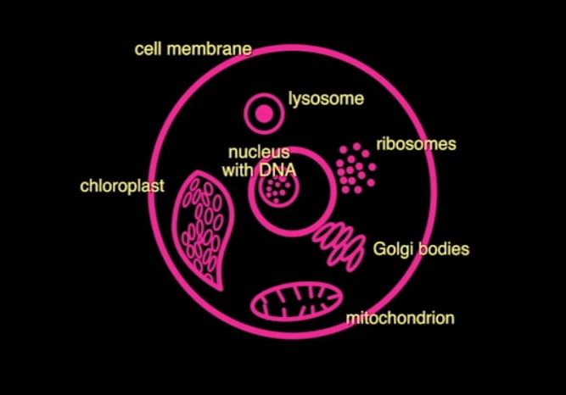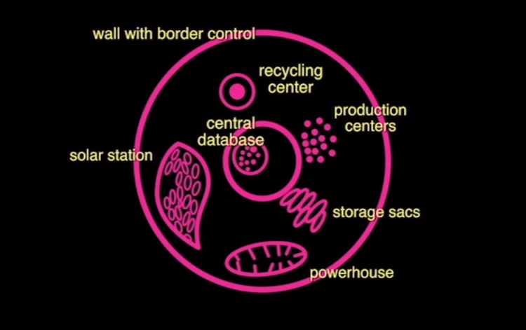
All parts of the cell work together like a community.
Neo-Darwinist hold that the DNA molecule controls the organism, but DNA is a part of the cell system and does not actively control anything. DNA can only be replicated and expressed. It is a storage molecule.
Until we stop using DNA as the unit of life and start using the cell as the unit of life, we are going to be continuing in the wrong direction.
DNA is not telling the cell what to do. It is the cell that reproduces, not the DNA. Barbara McKlintof described the gene as by controlling the reading of the DNA organ of the cell. The other parts of the system tell it what to do. The cell is in charge of its DNA, of access to parts of the DNA, and of expression of different data in the DNA.
How does the rest of the system tell the DNA what to do? Epigenetics!
Epigenetics is the study of changes in organisms caused by modification of gene expression rather than alteration of the genetic code itself.
Epigenetics is the study of the ways in which different genes are used at different times and places so that the same genome that you inherit in your fertilized egg can give rise to all the different cell types in the organism. It involves how the genes are being used. What you look like, what you act like is not merely a readout of a genome.
The metabolic network of the cell is influenced by the environment. What we eat, what toxic chemicals are in the air—these will affect our genetic processes. So are diseases caused by the genes or the environment, nature or nurture? It is always both.
Now it is frequent to see “according to this genome, you must have this and this disease, etc.” Immediately you must think of Lynn Margulis and you must realize that the environment at different levels is as important as the genetic constitution. The more we assume that the characteristics of the human are genetically determined, the less effort we are going to put into sustaining an environment in which people will grow up as humane humans.
The capacity to go against determinism is extremely relevant, because this gives to the human being, particularly, the possibility of thinking they are free. We are free to invent our future.
Who is this person walking toward me? She is a complex, metabolizing system. The entire system including her genome and microbiome, her culture and her environment, determines who she is and who she will become.

Chapter 9: Evolution Through Mergers
Margulis says, “I have often been troubled by the idea that the magnificent diversity of life came about by the natural selection of a string of accidents of random genetic mutations. This is the basis of the neo-Darwinian theory of evolution that s taught in schools. This is a gross oversimplification and it is wrong, because we now know a lot about the processes of variation. First of all we have learned that cells can repair coping errors so that they are reduced to a bare minim—less than one in a billion. The cell is not the helpless victim of random errors.
Genetic change is an active process that cells carry out on their genomes.
Mutations are not random. Mutations in particular areas can be influenced by the environment and physiology. The DNA is changed by a whole series of biochemical processes. These involve cutting and splicing DNA just as we do in the laboratory, which I like to call natural genetic engineering. Information flows from the environment and there is feedback to the genome.
The genome is a read-write system.
Cells deal with their genomes in a sentient manner, in a cognitive manner. They sense damage and take the appropriate steps to repair the damage. The cells are very smart. All beings on the planet are sentient beings. All! They make decisions and choices.
Life is matter that chooses.
All cells are cognitive. Is this thinking? “Thinking” is like “consciousness.” It is a word that is filled with philosophical implications and a lot of desire on our part to limit it to ourselves. Margulis prefers the word “cognitive,” because you can define it. Cognition is action based on sensory information.
Does the oak tree have cognition? The galls on oak trees are formed by wasps laying eggs on the tree. The cells are then reprogrammed to make a particular structure. What happened to that genome to make it reprogram? The oak gall is a symbiosis between an insect and a plant.
Margulis was a Darwinist. She differed with the Neo-Darwinists on the source of innovation, on where new species and new traits come from. Neo-Darwinists claim that you get new traits from mutations and from sexual recombinations. She agreed, but said that is a very small amount of changes. But for big, evolutionary changes such as speciation we have lots of examples that involve symbiosis.
Symbiosis is a key driver of evolution.
Symbiosis is a form of evolution distinct from Darwinian gradualism. Saltatory evolution prevails. Organism exchange and acquire genomes, which is called merger-integration-fusion processes. First is the symbiogenesis in all eukaryotes. Symbiogenesis is symbiosis leading to new kinds in evolution. What is so different is that it is not just the lichen that is the product of symbiogenesis, it is all animal cells, all plant cells, all fungal cells, and all protoctist cells—all life on earth that is not bacteria is a product of Symbiogenesis. Very different sorts of organisms came together to make a new kind of being. They are the product of recombining already refined parts developed by others to get something genuinely new. Her favorite example is green animals. These are green photosynthetic worms that lost their mouths and are very different from their immediate ancestors who are not photosynthetic.
Symbiogenesis is the mechanism of change in the fossil record and in evolution. Sometimes organisms swallow bacteria and take them apart incorporating the genome into the larger organism. In the human genome project, geneticists found strands of bacteria genomes within the human genome. See her book Acquiring Genomes: A theory of the Origins of Species by Lynn Margulis and Dorian Sagan.
The important variations that lead to evolutionary change come from the acquisition of genomes. This process is called “sex.” See her book Origins of Sex: Three Billion Years of Genetic Recombination by Lynn Margulis and Dorian Sagan. There are organisms that reproduce without sex and there is sex without reproduction and there is forbidden fertilization, which is sex between two very different types of organism. For example, a fungus is fertilized by a cyanobacteria resulting in a moss-like thing that is not a plant or moss at all. It is a new organism formed routinely b fusion between members of different kingdoms. This is called hybridization. Hybridogenesis is a powerful source of genetic novelty.
How does a caterpillar become a moth? How did this bizarre life cycle come to be? A controversial hypothesis this is a case of sequential hybridization. Another example is the plankton larva of the five-armed starfish. How can one animal from one egg diverge into two animals—one drifting away as a plankton and the other, the starfish, falling to the seabed to feed itself. The answer is hybridization. Usually fertilization of eggs and sperm takes place in water. If two unrelated groups spawn at the same time, there is the opportunity for some eggs to be fertilized by an unrelated species. In most cases, nothing happens. But once in a million years you get a viable hybrid called a sequential hybrid. First one animal if born from the egg and lives its life. This animal is called a larva. Then that animal transforms itself into a pupa. Inside the pupa enzymes digest the larva’s tissues leaving a rich gooey fluid, and from this egg-like fluid a second animal is born. So from one set of chromosomes two animals are born one after another.
Why is this theory so controversial? If it is correct, then our current understanding of animal evolution is fundamentally wrong and many scientific careers have essentially been wasted. It strikes at the core of Darwin’s tree model.
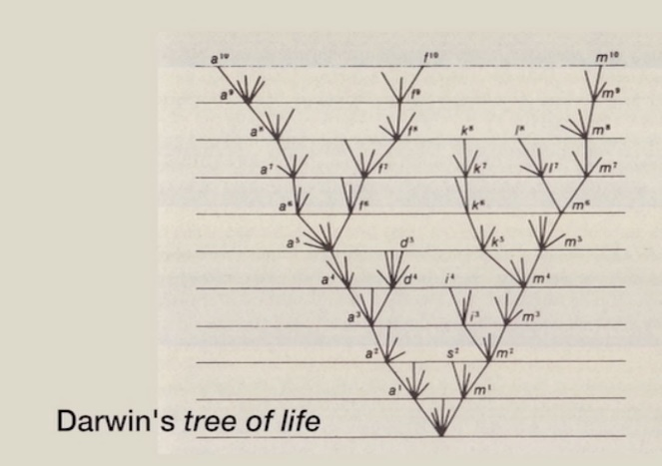
The tree is not the correct topology. It assumes that the lineages continue to branch from a common ancestor. Even this revised tree is wrong.
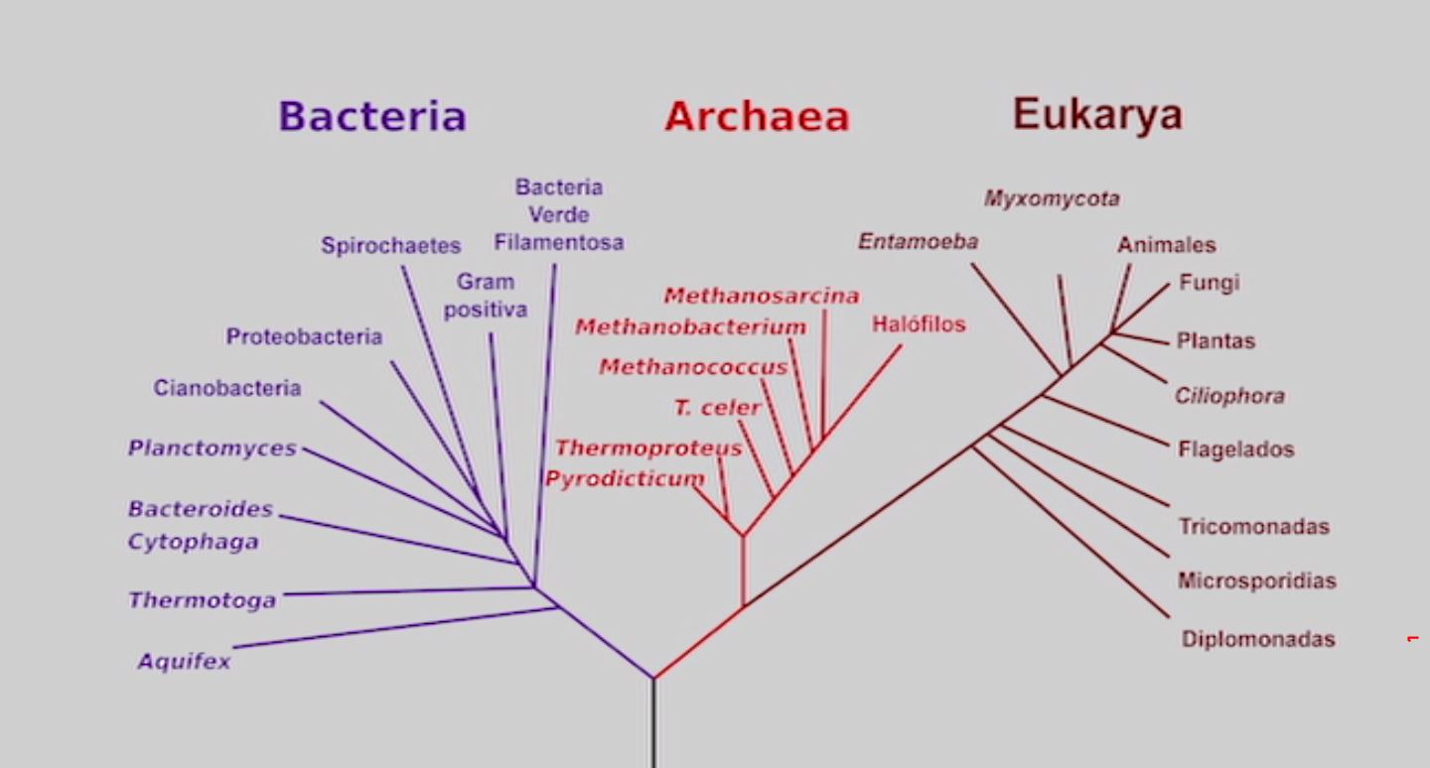
When genetic material moves from one branch to another the correct topology is a net or a web, not a tree.
In the Oxford debate between Margulis and Richard Dawkins, Dennis Noble, Stephan Bell, and Martin Brasier, there is a telling moment when Richard Dawkins says:
“But if you take the standard story for ordinary animals and what’s wrong with that? It is highly plausible, it is economical, and it is parsimonious. Why on earth would you want to drag in symbiogenesis?”
Margulis replies. “Because it’s there!”
Much of evolution remains an awe-inspiring mystery. Evolution is the growth and development of life from one cell to a living system with many interconnected and co-evolving parts, which covers the earth. Margulis would be quick to point out that the car, clothing and buildings in these photos may not be alive, but they are part of our living system, which evolves from generation to generation.

Chapter 10: Gaia: A Physiological System on the Surface of the Earth
Ina the early sixties scientists were asked to develop a life detection apparatus that can tell you that a planet has life on it. Asking the question has dramatically changed our view on life on earth.
The Gaia hypothesis says that you can detect life from the atmosphere of a planet. If the atmosphere is completely or almost at equilibrium then there is unlikely to be life on the planet. We are all connected by the atmosphere. It transports much of the matter that life uses to make itself. The atmosphere of Mars and Venus are almost all carbon dioxide with traces of other gases. This is a sign that they are dead planets.
The earth’s atmosphere is very different and this difference is a product of life. Our atmosphere is wildly out of equilibrium. We have a methane and oxygen mix. If they were in different proportions, they would blow up. Something must be regulating them. The Gaia hypothesis is that living organisms are regulating the atmosphere to keep the ratio in a range suitable for life. The lower atmosphere is not a passive environment. It is an actively modulated environment suitable for life on the surface.
Conventional wisdom held that l is a passenger on the earth, which was a dead ball of rock with a thin smear of life on the surface that did not have an influence on what the surface looked like. The geologists were in charge of the ball of rock and they didn’t really talk to the chemists and biologists. Thus we had a fragmented, reductionist approach to understanding earth.
John Lovelock challenged this with his book, Gaia: A New Look at Life on Earth. The Gaia notion is quite different. It sees the evolution of the earth and the evolution of life as one, single, tightly coupled process, an interactive system. The temperature remains constant because the sum of organisms and their activities have the potential to regulate it. Margulis contributed to Lovelock’s hypothesis by intuiting how this regulation could happen, because she was aware more than anyone of the role of bacteria in the infrastructure of the earth.
Bacteria are running the Gaia system.
There is something more than chemistry on the surface of the planet, and that is life. Margulis and Lovelock had a dynamic relationship bursting with creativity from their interdisciplinary fusion.
The Gaia hypothesis arose almost at the wrong time. Biologists were trying to purge the notion of things being for the good of the species or for the good of the collective as part of the theory of Neo-Darwinism. Dawkins stated:
I’m not happy to talk about the function of a particular gas in the regulation of the biosphere, because it implies that individual organisms that are manufacturing that gas are doing it for the good of the biosphere. It further implies that if it were bad for them, as individuals they might still do it because that is the only way the biosphere will persist. The real danger is that people will think that these individual organisms will sacrifice themselves for the benefit of the entire system. That is wrong. That is dangerously wrong in the sense that it is widely believe among laymen and even among professionals.
Neo-Darwinism, developed as a brand of Darwin’s great theory, seemed to be taken as the final last word on the subject, which is always dangerous. They wrongly assumed that Gaia was against it. They saw anything that looked like an argument for cooperation—and Gaia is the grandest argument in their eyes for cooperation—as being heretical to the theory. One senior scientists referred to Gaia as an evil religion. Margulis was always ready to fight them. Dawkins condescendingly referred to her as “Attila the hen,” but she was right and he was wrong.
Since all the mechanistic details were not yet worked out, people did not believe the Gaia hypothesis. We now know that, if it were not for life, the carbon dioxide in the atmosphere would be so great that we would be fried. Life has pumped it down continuously. This mechanism keeps the planet cool. A second mechanism to cool the planet comes from the clouds that are produced by the algae in the ocean.
The critics did not actually read any of the papers on the Gaia hypothesis. One problem was the name. Lovelock was searching for a four-letter word to focus the attention of his colleagues, when someone suggested Gaia, which means goddess of the Earth, and Lovelock thought that was wonderful. Purist scientists did not like the allusion to a goddess, but Lovelock stuck to it because it suggested that the earth is a living object. Margulis did not see the earth as an organism. She defined the earth as a physiological system made up of ecosystems, themselves made up of communities for which the minimum unit is the cell.
The filmmaker comments that perhaps Descartes’ famous expression “I think, therefore I am” should be changed to “We think, there I am.” I am a the product of communities of cognitive cells and symbionts that make up my body and the product of the social and ecological communities of which I am a part and together we are Gaia, a symbiotic earth.
Lovelock explains that we are part of the earth and we have sentience. This is why Gaia is a sentient entity, because we are an important animal species in it. We let it see itself for the first time. We are, through our intelligence and communications, in a way the nervous system of our planet. We can’t help being a part of it. So we should be the heart and mind of the earth, not its malady. I’m trying to show you that Gaia provides and intellectual habitat where understanding of the earth can evolve and grow. Perhaps its greatest value lies in its metaphor of a living earth. It reminds us that we are part of it and most of all that there are no human rights, only human obligations. It is becoming a live thinking planet. Think where it is going to go! We are only a stage in the evolution. I’m optimistic.

Epilog
Margulis was awed by life. That was as close to spirituality as she would get. She was driven to understand it. When she was a little girl, she wanted to be an explorer. She was genuinely curious and smart enough to interpret the world as a scientist. She studied termites all her career. In order to digest the wood they eat, termites rely on symbiotic protists that live in their gut. The protists each include a community of bacteria. One protist, Mixotricha paradoxa, is a beast with five genomes. It has a community of spherical bacteria in its gut, three different bacteria on its surface, and two kinds of spirochete bacteria, these forming communities of bacteria within communities of protists within communities of termites within ecosystems within Gaia.
What plans did Margulis have for the future of science? They were very simple. They are the same as they were forty years ago. She won three out of four of her battles. She won the archaebacteria nature of the cytoplasm, the mitochondria and the chloroplasts, but they still would not publish her work on spirochetes. She wanted to win four out of four. Her last book Symbiogenetics: The origin of mitotic cells from bacterial communities in the Proterozoic era (November 11, 2011) remains unpublished.
Blaise Pascal believed that knowledge is like a sphere. The larger it gets, the larger the surface gets, which is the boundary to the unknown. As knowledge grows, the unknown grows.
Lynn Margulis gave us a new way of thinking about life. She gives Emily Dickenson the last word about biologists in the last stanzas of “What mystery pervades a well.”
But nature is a stranger yet:
The ones that cite her most
Have never passed her haunted house,
Nor simplified her ghost.
To pity those that know her not
Is helped by the regret
That those who know her, know her less
The nearer her they get.

Sym-bio from the Greek, living together.

A film by John Feldman. Hummingbird films. 147 minutes. www.bullfrogfilms.com. Margulis challenged the male-dominated scientific community and proposed a new approach to understanding life.
A mycelium may be minute, forming a colony that is too small to see, or it may be extensive: Is this the largest organism in the world? This 2,400-acre [970-hectare] site in eastern Oregon had a contiguous growth of mycelium before logging roads cut through it. Estimated at 1,665 football fields in size and 2,200 years old, this one fungus has killed the forest above it several times over, and in so doing has built deeper soil layers that allow the growth of ever-larger stands of trees. Mushroom-forming forest fungi are unique in that their mycelial mats can achieve such massive proportions. — Paul Stamets, Mycelium Running^{[1]}

