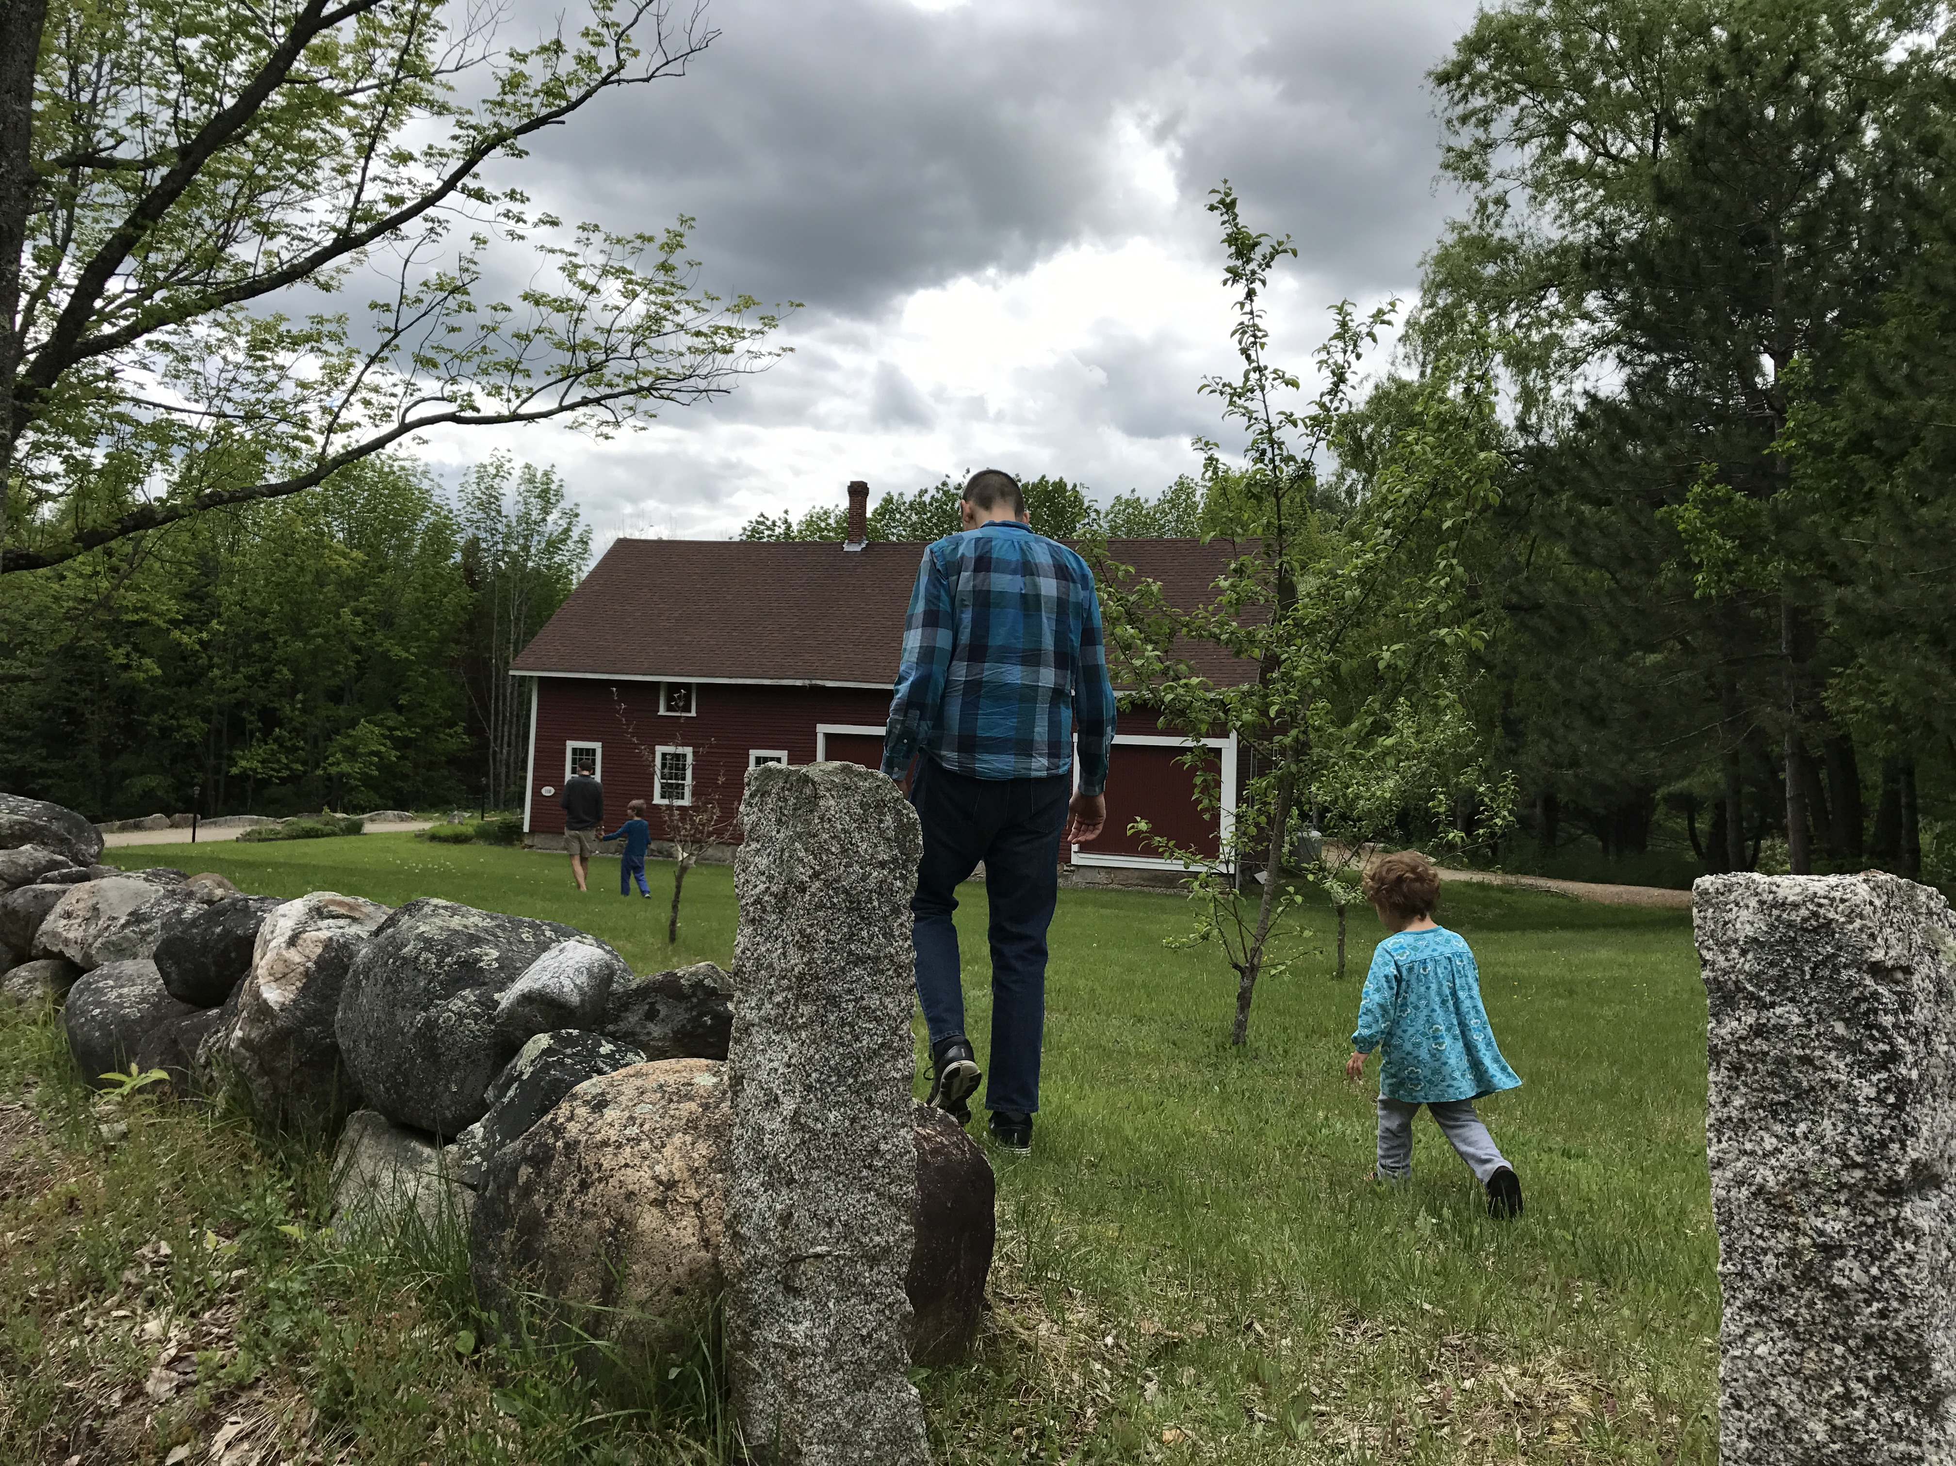 Please Join Us!
2019 Family Retreat, Memorial Day Weekend
Saturday, May 25 – Monday, May 27
Notre Dame Spiritual Center, Alfred, Maine
Come together to share fellowship, outdoor play, nature walks, and worship in beautiful Alfred, Maine. Our annual retreat begins at lunch on Saturday at noon, ending early afternoon on Monday.
Adults and children age 12 and up: $150 for the weekend
Children age 5-11: $75 ; Children 4 and under: no charge
Any questions, please contact Greg Woods youthministries@fmcquaker.org 413-251-6512
REGISTRATION DEADLINE: Wednesday May 8
Registration Form
Name of Adult(s) Attending: ___________________________________________________
Name(s) & Age(s) of Children Attending: ___________________________________________________
Email Address(es): ___________________________________
Phone # ____________________________________________
Dietary Restrictions __________________________
What meals will you be attending?
___ Sat Lunch ___ Sat Dinner ___ Sun Breakfast
___ Sun Lunch ___ Sun Dinner ___ Monday Breakfast
Rides: __ Needed __ Offered (___ # can take)
Drop off form & check at the office or mail: Friends Meeting @Cambridge, 5 Longfellow Park, Cambridge, MA 02138. Payable to Friends Meeting at Cambridge
Amount I can contribute $________ Donation towards Scholarships $_________ Scholarship Amount Requested: $____________
Safety Commitment: Parents/guardians, please note that we take responsibility for our own children’s safety throughout the weekend. FMC does not provide official childcare workers for this retreat. Also, since it is an intergenerational, community-building event, attendees (adult and youth) must commit to abstaining from the use of alcohol/illegal drugs.
In addition to these basic expectations, on our first day together we will have a community meeting and discuss how we can all ensure a safe and fun weekend for all.

